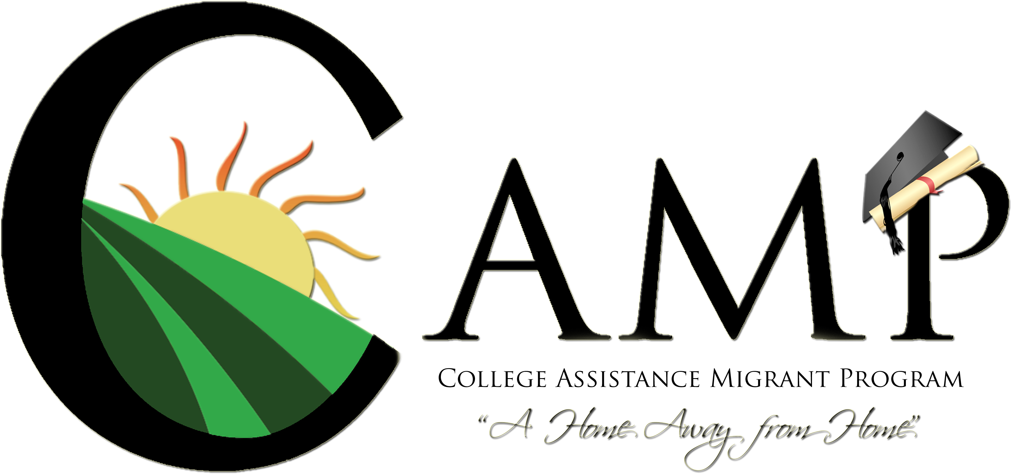

CALIFORNIA STATE UNIVERSITY, SACRAMENTO
COURSE SYLLABUS – SPRING 2017
Ethnic Studies 94: CAMP Transition and Problem Solving
Fridays 3:00 p.m. – 5:00 p.m. Riverside Hall 1015

Facilitators: | Jessica Arauza  jessica.arauza@csus.edu |  | Mayra Villarreal  camp-14@csus.edu
 | 916-278-4273 |  | 916-278-4274

“We are what we repeatedly do. Excellence therefore is not an act but a habit.” — Aristotle

Course Description:
Designed for CAMP students, the course is focused on assisting students make a successful transition to the University. In particular, the course is designed to give space for students to explore the various aspects of their identity, the power of their personal stories, and how they can use their stories as a means to enact change in their immediate and larger communities.

Course Goals/Learning Outcomes:
By the end of the course, students will be able to:
- Describe various theories on identity and how to apply them to their own lives.
- Identify ways they can utilize their personal challenges and barriers as a way to showcase their persistence and personal strength.
- Describe the role of activism in social movements and how these in turn have lead to social and political changes in the United States.

Required Reading:
All readings for this class will be accessible online via the Weebly course page. You can access the page here: http://csuscampclass.weebly.com/

Important Note:
The facilitators reserve the right to change or alter parts of the scheduled readings and syllabus as deemed necessary.

Course Requirements:
Attendance and Participation
- Class time provides you an opportunity to learn concepts, voice your opinions and/or concerns, as perspectives. If you miss more than 3 classes your grade will be affected as it will be lowered by one grade for each absence over 3. If any of these absences is a result of an emergency, illness or any other extenuating circumstance, special documentation may be needed to excuse the absence.
- Your voice matters in this class. Asking questions, providing your perspective and engaging in dialogue are all part of the learning process. You will have an opportunity to participate at the class level as well as in small group formats.

Course Assignments and Extra Credit
- All assignments must be submitted on time. This means that all assignments must be submitted to the facilitators by the beginning of the class (e.g. 3:00 pm). Prior approval must be given for late assignments. For each day that an assignment is late, the assignment will be lowered one letter grade.
- Extra credit work may be accepted with instructor’s prior approval.

Readings
- Readings need to be completed by the date they are to be discussed.

Course Policies:
- Laptop and cell phone regulation: No use of laptops, cell phone text messaging, or music devices is allowed during class. Specifically, please avoid point deductions when engaging in these options casually versus emergency related circumstances.
- If you have a disability and require accommodations, you need to provide disability documentation to SSWD, Lassen Hall 1008, (916) 278-6955. Please discuss your accommodation needs with me after class or during my office hours early in the semester.
- No plagiarism. Plagiarism and academic dishonesty will not be tolerated! Please refer to http://library.csus.edu/content2.asp?pageID=353 for more information.

DESCRIPTION OF ASSIGNMENTS

Formatting for all Reflection Papers
Double-spaced, 1-inch margins all around, 12 point Times New Roman font, and a cover page (title of the assignment, your name, the facilitator’s names, date, class name and time) are required. The cover page is not included in the total count of an assignment.

Reading Journals
As an effort to assist students with readings for this course, students will have to submit reading journals. These will be notes that they will need to submit the week following the assigned readings. A prompt will be provided to assist.

Serna Center Event Reflection Papers
Reflection papers will be 2 pages in length and based on a question assigned at the end of the previous week. Reflection papers will be graded on content and how well the topic question is answered using critical thinking and proper grammar. Your reflection should explain how presented models or theories apply to your personal experiences and experiences as a student.

Leadership Initiative (LI) Reflection Papers
To assist students in continuing their leadership development, we will be incorporating the Leadership Initiative: Hornet Pride Certificate into the course. Students will participate in the two workshop sessions for the certificate in class. At the completion of each workshops, you will be prompted by the Student Organizations and Leadership: Leadership Initiative (SOL: LI) staff to complete a reflection for the workshop. Your assignment for this class is to submit this reflection after it has been submitted to SOL: LI. Both reflections will need to be submitted by the last class of the semester.

Midterm Project: Social Issues Group Project
For the midterm project, students will be placed in groups of six and will be tasked to conduct a 5 minute informational presentation on a pre-selescted social issue. Students will be asked to conduct research on their specific topic; delineate the major problem within the issue; provide some potential solutions to the problem; and potential career opportunities within these fields. More detailed prompts will be provided further in the semester.

Final Project: Engaging in Your Personal Narrative Essay
For the final project, students will be asked to utilize theories and concepts that have been introduced throughout the semester and speak on how they can utilize their voice in advocacy and how to become agents of change within their communities. More details will be provided further in the semester.

Spoken Word Contest
At the end of the semester, CAMP will be hosting a recognition ceremony for this year’s CAMP cohort. As part of the ceremony, we would like to have two students perform a spoken word piece on their identity and how they can use their new found knowledge to become agents of change. Students interested in this opportunity will submit their entries at the end of March. Those selected will not have to submit a final project. More detailed will be provided further in the semester.

CAMP Community Service Requirement Reminder
As a requirement of the CAMP program we are asking that you complete a total of 20 hours of community service for the academic year. CAMP will provide many volunteer opportunities such as student panels, campus tours, outreach visits to high schools, etc. CAMP will keep you posted of the various volunteer opportunities that will be available throughout the next year.

EVALUATION

Assignment | Points Each | Total Semester Points
Serna Center Reflection Papers | 10pnts each x 5 papers | 50
Leadership Initiative Reflection Papers | 10pnts each x 2 papers | 20
Reading Journals | 10pnts each x 3 journals | 30
Midterm | 60pnts | 60
Final | 60pnts | 60
Attendance/Participation | 3 (3pts each x 15 classes) | 45

Total Points Possible: 265

GRADING SCALE

A = 100 – 94% | B+ = 89 – 87% | B- = 83 – 80% | C = 76 – 74% | D = 69 – 60%
A- =93 – 90 % | B = 86 – 84% | C+ = 79 – 77% | C- = 73 – 70% | Below 60% not passing grade

COURSE CALENDAR

DATE | TOPIC / READINGS | HOMEWORK
1/27 | Introduction to Spring 2017 semester—  - Course expectations  - Review of syllabus  - Announcements  - Reading Journals
2/3 | Leadership Initiative: Hornet Pride Workshop  Identity, Social Issues, and How these Relate to Our Identities  - Nickesia S. Gordon: “To Talk or Not to Talk, Should that Be the Question? How the Double Jeopardy of Race and Nationality Influence My Experiences in Academia” | DUE: Reading Journal 1
2/10 | Serna Center Leadership Series: “Join an ASI Committee Workshop”  (Location: Hinde Auditorium)
2/17 | CAMP Scholars Presentation  The Power of Your Story  - Jeffery Duncan-Andrade, “Note to Educators: Hope Required When Growing Roses in Concrete”  - https://www.youtube.com/watch?v=2CwS60ykM8s  The Power of Your Story Project | DUE:  - Reflection Paper 1: “Join an ASI Committee Workshop”  - Reading Journal 2
2/24 | Sacramento Chicana Activist Panel  (Location: Terrace Suite, The WELL)
3/3 | Reading Partners Presentation – Shannon Butler  Peer Health Educators Presentation | Reflection Paper 2: “Sacramento Chicana Activist Panel” (submit online)
3/10 | Cesar Chavez Legacy Week: Briefing on Farmworker Policies  (Location: Hinde Auditorium)
3/17 | CAMP/HEP Outreach Leaders Program Presentation  CAMP Leaders Presentation  Social Movements in the United States  Current Social Issues Group Project | DUE:  - Reflection Paper 3: Briefing on Farmworker Policies  - Reading Journal 3
3/24 | Spring Break – No Class
3/31 | Cesar Chavez Birthday – No Class (Campus Closed)
4/7 | Serna Center Success Chat: Sensible Judgement: Negotiating between Family and College  (Location: Ballroom III)
4/14 | Leadership Initiative: Hornet Pride Workshop  Group Presentation Work | Reflection Paper 4: “Sensible Judgement: Negotiating between Family and College”
4/21 | Group Presentations
4/28 | Serna Center Success Chat: “Building Healthy Habits”  (Location: Hinde Auditorium)
5/5 | Final Project Submission  CAMP Evaluations  Year 1 Wrap Up | Reflection Paper 5: “Building Healthy Habits”
5/12 | CAMP End of the Year Recognition Ceremony
5/15-5/19 | Finals Week – No Class

Reading Journal Template

